Online basic R Lectures

Class project: R library for climate change analysis – RCCC (R Climate Change CRONOS)
Objective
Create an R library able to retrieve weather data from the CRONOS (http://www.nc-climate.ncsu.edu/cronos) database and plot the following information for the selected weather stations:
- Yearly accumulated rainfall.
- Mean monthly rainfall.
- Yearly mean of temperature across the years.
- Yearly mean of the maximum temperature across the years.
- Yearly mean of the minimum temperature across the years.
- First occurrence of more than 25mm (1 Inch) of rainfall in less than 3 days after start of spring (begin of the rain season).
- Number of days over 35⁰C (95⁰F) across all years.
- Date of the first day with temperature <0⁰C (32⁰F) after begin of fall.
- Date of the last day with temperature <0⁰C (32⁰F) until begin of spring.

Examples of Graphs that will be produced
Mean temperature over the years
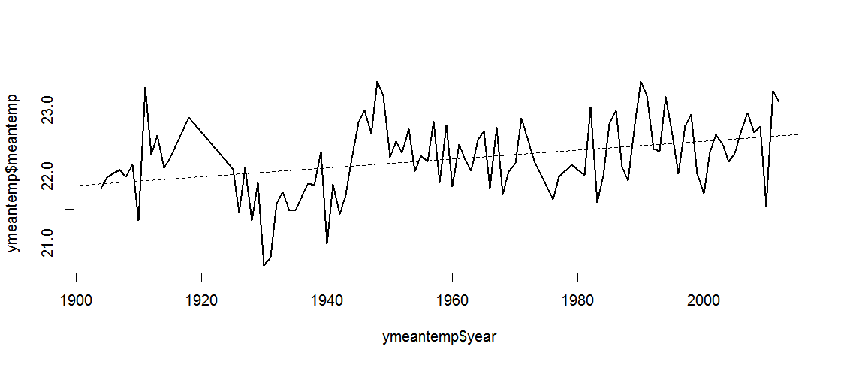
Day of the year of the first winter frost (day of year)
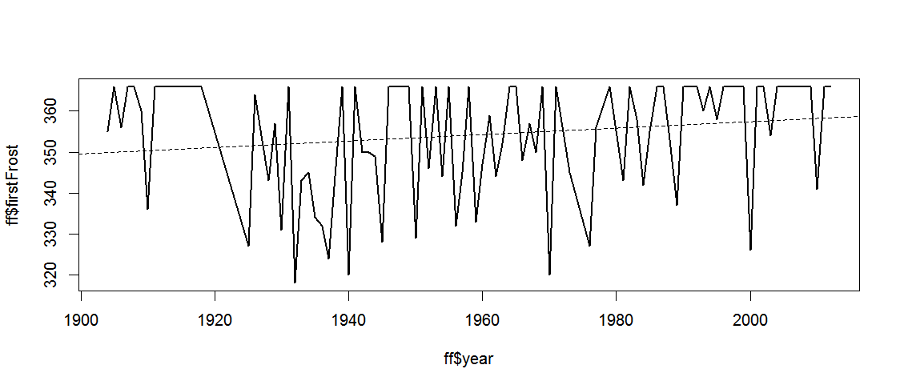
Day of the year of the last frost (day of year)
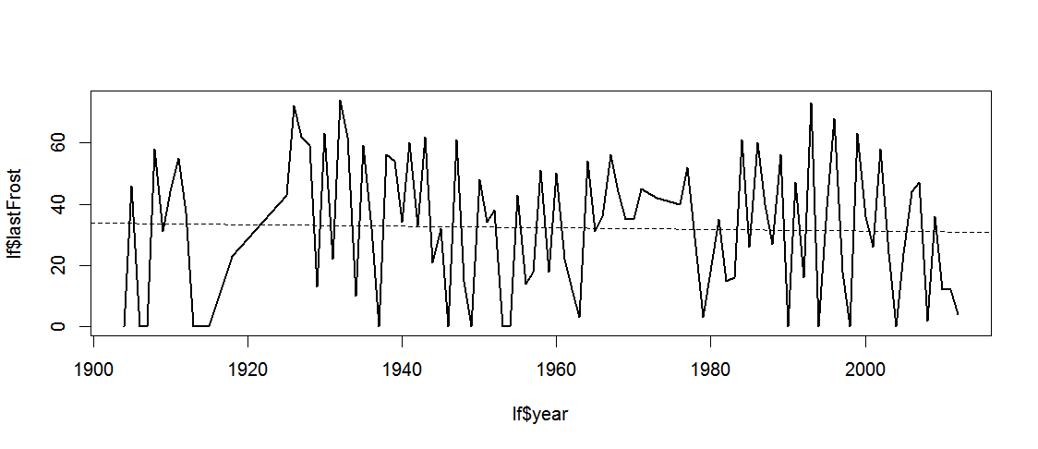
Mean rain of every month (inches)
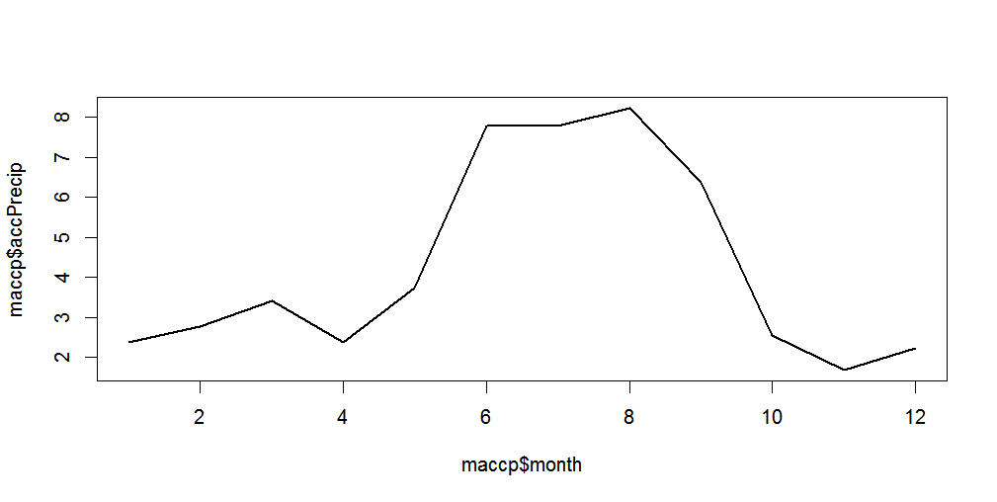
Beginning of the rain season (day of year)
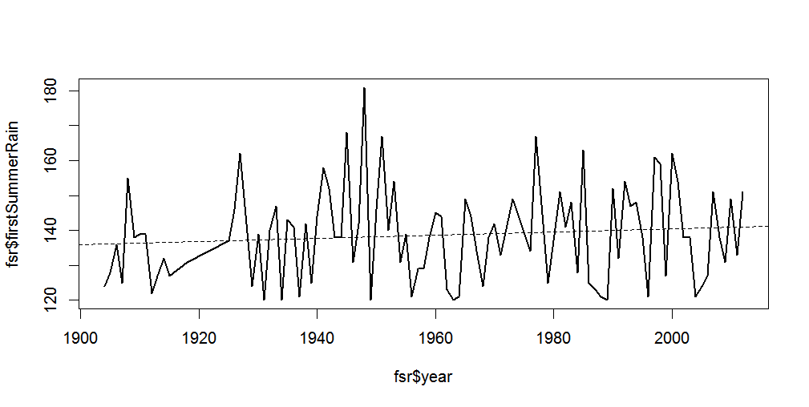

Course links
Lecture 1 - Overview of the online basic R tutorial - http://youtu.be/Ups49fkux5A
Lecture 1.1 Optional - Why should I learn R - http://youtu.be/eORsF1FRssk
Lecture 2 - What is going to be covered - http://youtu.be/T86nz40YaU0
Lecture 3 - Getting started (installation) - http://youtu.be/bBcMCzqAwHE
Lecture 4 - Basic data manipulation - http://youtu.be/Wk3vEyQP5Uw
Lecture 5 - Basic data manipulation 2 - http://youtu.be/EJhC3xLfxdw
Lecture 6 - Data manipulation exercise solving - http://youtu.be/Uuh5Bh3IDPQ
Lecture 7 - Data types - http://youtu.be/93ovbFOMblQ
Lecture 8 - Data types 2 - http://youtu.be/6NtnzgSLCpY
Lecture 9 - Import and export data with R - http://youtu.be/fnke98HoSFs
Lecture 10 - Characters - http://youtu.be/A0Qv7szwkkw
Lecture 11 - Date/Time - http://youtu.be/lSLMHKKdQpY
Lecture 12 - Date/Time exercise solving - http://youtu.be/Px_ghIREOg0
Lecture 13 - Vectors - http://youtu.be/WM7gvWYAH-8
Lecture 14 - Conditional statements - http://youtu.be/zSDsC7ZV61o
Lecture 15 - Vectors and conditional statements exercise - http://youtu.be/SD96GtBonXU
Lecture 16 - Matrices - http://youtu.be/9xqlMVlCSbU
Lecture 17 - Looping structures in R - http://youtu.be/dxVFxBOVsXA
Lecture 18 - Loops exercise solving - http://youtu.be/VhbAKXD0lTs
Lecture 19 - Functions - http://youtu.be/c1B5TOiSNSE
Lecture 20 - Plot and Graphs - http://youtu.be/N_ow5_a14K8
Lecture 21 - Advanced data processing - http://youtu.be/cDYTQXC5KVM
Lecture 22 - Project final code overview - http://youtu.be/zkEUQxoIyjk
Lecture 23 - R packages and closing remarks - http://youtu.be/OB5VlLRq4mc
Lecture 24 - (Optional) Efficient work environment - http://youtu.be/mPmO30nGOwk
Lecture 25 - (Optional) Examples of R usage in my work - http://youtu.be/lHavpSPqXpo

Tiago Zortea
tiagozortea@hotmail.com

